SilverScreen

Use-Case: Edit Settings

Version 1.0

Revision History

|  |  |  |  |
| --- | --- | --- | --- |
| **Date** | **Version** | **Description** | **Author** |
| 23.11.2016 | 1.0 | Initial draft | Fabian Blatz |
| 8.12.2016 | 1.1 | Added some Mockups | Fabian Blatz |
| 30.12.2016 | 1.2 | Added the feature Code | Fabian Blatz |
|  |  |  |  |

Table of Contents

1. Use-Case Name 4

1.1 Brief Description 4

2. Flow of Events 4

2.1 Basic Flow 4

2.2 Alternative Flows 4

3. Special Requirements 4

4. Preconditions 4

5. Postconditions 4

6. Extension Points 4

Use-Case Specification: Edit Settings

# Use-Case Name

## Brief Description

The User enters a activity where he can change multiple settings regarding the behaviour of the application e.g. whether to prevent the app from loading movie posters to save traffic or not.

# Flow of Events

## Basic Flow



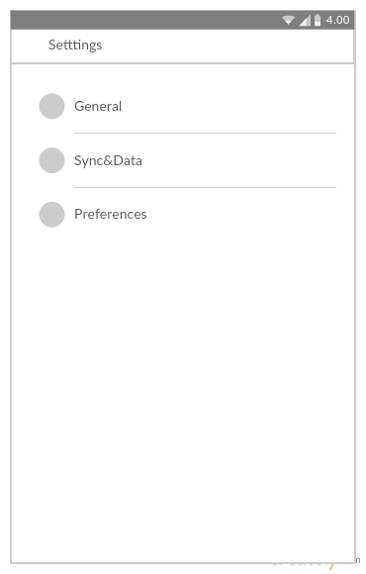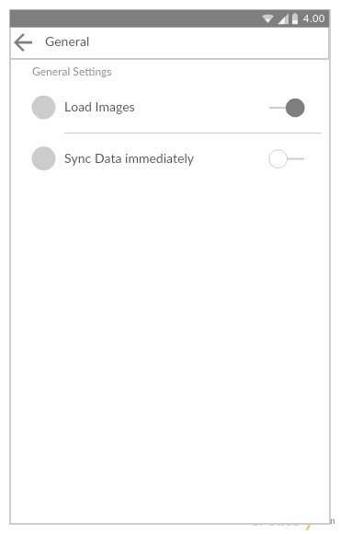

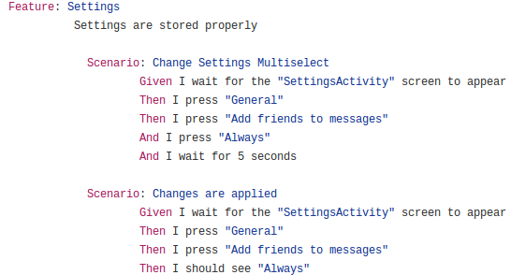

## Alternative Flows

#### None

# Special Requirements

None

# Preconditions

The user has an activated account and is logged in.

# Postconditions

Settings are applied, settings are saved as JSON to a file.

# Extension Points

None